HEAVY MECHANICAL

**HMC**

COMPLEX (PVT) LIMITED

A Company of State Engineering Corporation Ministry of Industries & Production Government of Pakistan

**Ref: No. HMC/786/0104 Dated: <To2>**

**TO WHOM IT MAY CONCERN**

It is certify that Mr. <Name> S/o <fname> has worked with us as a <Designation> from <From2> to <To2>.

He worked well done with us in our Project. He proves his self to be right man for this post. During his working period we found him very hardworking, co-operative, honest and dutiful in this job. He is very obedient and hardworking person.

We wish him success in his future life.

**MANAGING DIRECTOR**

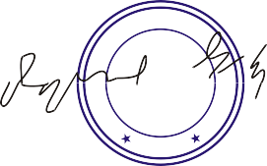

**ISO 9000 CERTIFIED**

**Taxila 47050, Pakistan 0092-51-9270562-67 (6 Lines) & 0092-596-535591-99 (9 Line)**

**Ph: 0092-51-9270560, 0092-596-2701 & 536509 Web Site: http:\\www.hmc.com.pk**

**E mail: hmc@paknet.net.pk**